Fr. Conceicao Rodrigues College of Engineering, Bandra (W)
SE Electronics & Computer Science (SEM III)
Mini Project-1A Proposal Form
AY -2022 - 23

Name of the student(s) with roll numbers
- RATAN SINGH [ ROLL NO.: - 9511]
- AARUSH WASNIK [ ROLL NO.: - 9517]
2. Title of the Mini Project:
“WEB SEARCH ENGINE- For Turf Booking”

- Mini Project Category:
Research | √ | Software | √
Application | √ | Hardware
Product |  | Software and Hardware

- Mini Project Area/ Problem Characteristics:
Analog Circuits |  | Software Tools | √
Digital Circuits |  | Mobile Application
Micro-Controller based circuits |  | DBMS/Data Structure Application | √
Basic Science/Engineering |  | Social/Environmental issues
Others (Please Specify)

Background
In this rapidly developing world, the area available for outdoor activities has been reducing day-by-day or another option available for people is to book a turf for a limited period. Also, in the public open ground, there are more chances of getting restricted in a particular area or there might be disputes taking place among the people. So, nowadays people prefer to play on turf rather than on the open ground. But the problem faced by the user/people is that they don’t have enough resources or a single platform where they can browse and book the turf with the best deal without doing any manual work for a long period. So, we decided to develop a web search engine that will provide all the required services to the user.
The main characteristic of our platform is that it is not a website designed for turf booking but it’s a web search engine that will be hosting all the best deals available on that particular turf. It will sort all the turf with the best deal within the selected price range with most of the amenities and services and also based on ratings given to the turf and their location.
5 A. Mini Project Abstract:
Area: - Sports Resource Management System.
PURPOSE: - This study aims to design a web search engine for Turf Booking to evaluate the best deal for the users while booking their turf along with other add-ons. Thus, it becomes a one-stop Platform where users can compare and select the most satisfactory deal for them.
DESIGN: - We will be using simple web development languages to build the web search engine which will perform reliability analysis to get the best deal with the help of measurable scales such as rating, amenities, price range, chatbot, and much more. We will be using Html and CSS for the frontend development of the search engine and the backend part, we will be using Node JS i.e., Xpress JS for the framework.
ORIGINALITY: - This is one of the first web engines that analyses the input resources and sorts using algorithms and displays the required output especially used for turf booking.

5 B. Project Objectives: -
- To determine the keyword and then used a search algorithm mostly binary search and find the most accurate output.
- Using various filters (such as rating, amenities, and price range) as keywords to find the most accurate search result.
- Using a sorting algorithm with condition term frequency of filter keyword.
- To use various front-end and back-end applications during the course of development.

Technical Feasibility: -

The Entity – Relationship Diagram for the Web Search Engine is given below: -
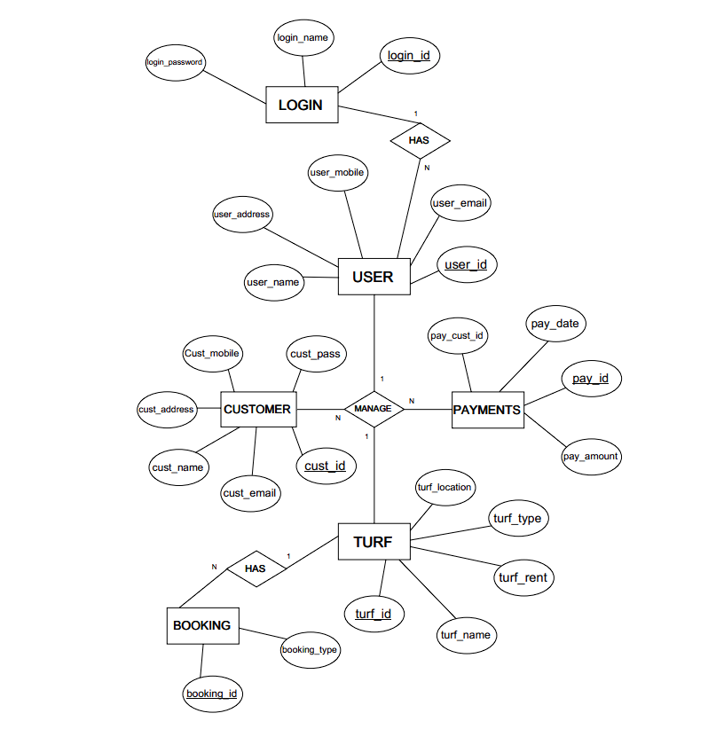

System Requirements

Software Requirements
Frontend: -
- HTML.
- CSS
Backend: -
- Node JS
- Express JS
- MongoDB
- What is the Novelty / Innovation/ Social relevance of the proposed project?
A customized web search engine specifically for turf booking. The only search engine for turf booking.

References: -
    - Google Scholar

    - Web Technologies used by Trivago. be (w3techs.com).

    - YouTube

    - GeeksforGeeks | A computer science portal for geeks

Research papers: -

bc6c49d1-4dff-4cd6-8137-e567d1398cc91633534502428344331.pdf (nihb.ac.in).

(PDF) Design and Implementation of an Online Booking System for University Sports Venues (researchgate.net)

On The Design of Web-Based Information and Booking System For Futsal Field Rental Business |PDF | Android (Operating System) | Mobile App (scribd.com).

